Español 3

Allie Bouchard
Room 204
abouchard@wcpss.net
www.senoritabouchard.weebly.com
Twitter: @SrtaBouchard
SMART Lunch Tutorials: Monday: 1st Period, Tuesday: 2nd Period, Wednesday: 3rd Period

Supplies Needed
- 3 ring binder
- Notebook paper
- Pencils
- Pens

Class Rules
Be Prepared
- Be seated and ready to begin working when the bell rings.
- Bring all necessary materials (pencil, paper, homework etc.) to class every day.
- Refrain from using your cell phone or other electronic devices in class unless otherwise instructed by the teacher.
Be Respectful
- Respect the ideas, contributions, and personal space of your teacher as well as your classmates.
- Remember to raise your hand before speaking and save side conversations for outside of the classroom. It is important that all students in the class have an opportunity to contribute and feel heard.
- Remember, you represent Leesville Road High School and you are expected to abide by the school rules outlined in the Student Handbook.
Be Confident
- Answer questions, ask questions, and speak with your classmates (in Spanish). Remember, it’s okay to make mistakes, just try your best!

Attendance/ Absences
Attendance in Spanish class is mandatory. Parents/guardians can expect to be contacted following repeated absences.

Students are responsible for their own work. If a student is absent, they should visit me during my SMART lunch tutorial days to get their missed work. In accordance with the LRHS Handbook, if the absence is excused, students will be given one day for each day absent for absences from one to three days to make up their work and two days for each day absent for absences exceeding three days.

Any work assigned prior to an absence (ie. project) is due upon the student’s return to school.

Grading Procedure

All grades will fall under one category, “trabajo”, and will be an average of total points.

Homework is assigned nightly in an effort to reinforce the concepts we cover in class. It will be checked for completion and reviewed in class the following day. Homework assignment will be posted on my website www.senoritabouchard.weebly.com.

Late Work Policy
If a student turns in an assignment (classwork or project) late, 10 points will be deducted from the grade for each day it is late.
SMART Lunch Grade Recovery
Any student may complete corrections on any test or quiz worth 50 points or more. Corrections must be made within one week after the graded assessment has been returned.
The student must first come to SMART lunch one day to make a study guide based on their results. During this time they can confer with a tutor and/or teacher to understand the mistakes.
The student must then come to SMART lunch on a second day to complete the test corrections. At this time the student will correct their original mistake and explain in English why the “new” answer is right. For each correct response accompanied by an appropriate explanation, the student will earn half credit. Students may not use notes, electronic devices, or confer with anyone during this part of the process.

Please do not hesitate to contact me at any time during the semester if you have questions, comments, or concerns. The most efficient way to get in touch with me is via email (abouchard@wcpss.net).

Maintaining communication with parents is extremely important to me. Please provide a phone number and email so that I can keep you informed of our progress in Spanish class.

Please sign this document and return it to Ms. Bouchard. Your signature means that you have read through and understand the class policies and procedures and have familiarized yourself with the WCPSS student code of conduct.

Student name __________________________ Signature ___________________________

Parent/Guardian Name __________________ Signature __________________________

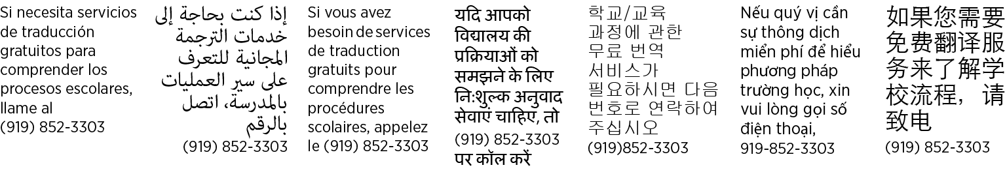
Parent/Guardian phone ____________________ Email ____________________________

